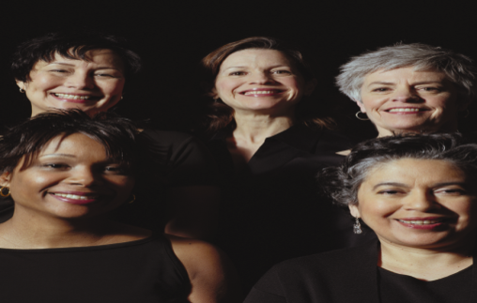
REACH AND CONNECT

Reach and Connect is a project under the Florida Breast and Cervical Cancer Early Detection Program (BCCEDP). This project provides education and support to for Bay, Calhoun, Franklin, Gulf, Holmes, Jackson, Liberty, Walton & Washington counties. Areas in those counties have been identified as having higher rates of late stage diagnosed breast and cervical cancer cases. Your local Community Health Worker will provide toolkit training, follow ups, resources and support to connect women to services and reduce barriers to screening.
Educational Presentation developed for small groups of women in community based and faith based settings. | Increase your knowledge about:  - Breast cancer  - Cervical cancer  - Human papillomavirus (HPV)  - Importance of getting regular breast and cervical cancer screenings

The Community Health Worker is available to present Breast and Cervical Cancer “Piece of Mind” toolkit and education in your community!
Contact Your Community Health Worker to Schedule a Presentation

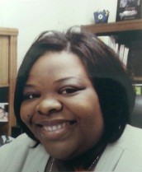
Katrice Davis
850-526-2412 Ext 206
Katrice.Davis@flhealth.gov

Click for more information about HPV
http://www.cdc.gov/vaccines/who/teens/vaccines/hpv.html

