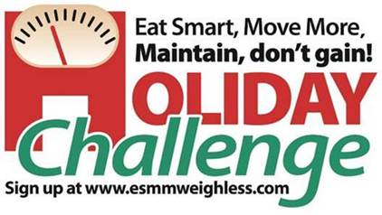

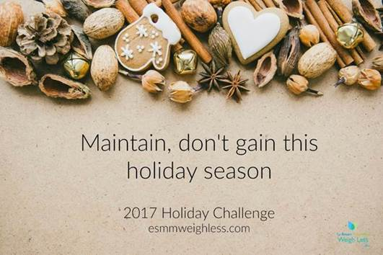

**The 2017 Eat Smart, Move More, Maintain, don’t gain! Holiday Challenge**

This holiday season, the only thing that should be “stuffed” is the turkey.  Many Americans gain between 1 and 5 pounds each holiday season. While it may not sound like much, most people never manage to lose these extra pounds.

Last year's Holiday Challenge was the largest to date. Over **15,600** participants from all 50 states, all 100 NC counties, and 13 additional countries joined the Holiday Challenge. Now it's time for the 2017 *Eat Smart, Move More, Maintain, don't gain! Holiday Challenge*!

You are invited to join the 11th annual Holiday Challenge. Rather than focusing on trying to lose weight, this **FREE** seven-week challenge provides participants with tips, tricks, and ideas to help *maintain* their weight throughout the holiday season.

The Holiday Challenge will begin **November 13th and run through December 31st**.

[cid:image003.jpg@01D35D4A.15A27DD0](https://esmmweighless.com/holiday-challenge-live/)

If the link is not working, please go to [esmmweighless.com](http://esmmweighless.com) and click the Holiday Challenge tab.

**Last year's Holiday Challenge:**

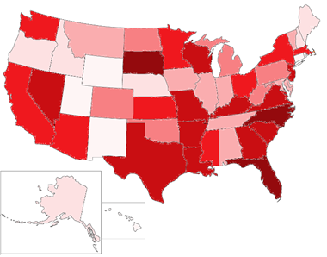

In 2016, more than 15,600 people from all 50 states took part in the Holiday Challenge. All 100 counties in North Carolina were also represented. At the end of the program, 92% reported maintaining or losing weight. 98% of participants said they were likely to participate in the Holiday Challenge again next year. For more results and to see how your state ranked in participation, click here: [Holiday Challenge Results](https://esmmweighless.com/wp-content/uploads/2016/09/2016-Holiday-Challenge-Wrap-Up-Report.pdf).