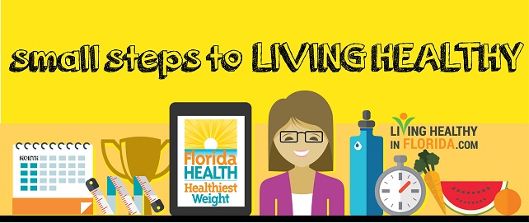
Be in the Know
According to the National Institutes of Health, alcoholic beverages are high in calories, but low in nutrients and may lead to unhealthy weight. The National Institutes of Health offers this free drink calorie calculator to show you the calories you consume per week from alcohol beverages.
Regular physical activity and a balanced diet are necessary to achieve and maintain a healthy weight. If you are losing weight, it is important to do so slowly, at a rate of about 1/2 to 2 pounds a week. To lose 1 pound a week, you need to consume 500 fewer calories a day than your body burns. It's best to combine eating (and drinking non-water beverages) less with being more physically active.
Make sure to add your goal of 10,000 steps a day to help with your healthy weight loss.
Fresh from Florida Recipe of the Week
Fresh from Florida offers a way to spruce up water to make it more enjoyable using Florida cucumbers. Cucumbers are a good source of vitamin K. Consider swapping out an alcoholic beverage for a glass of this refreshing water using in-season Florida cucumbers and oranges:
Florida Water
- 1 cucumber, cut into 1/4 –inch slices
- 2 lemons, cut into 1/4 –inch slices
- 1 orange, cut into 1/4 –inch slices
- 1 gallon water
Directions:
Mix all ingredients together. Refrigerate overnight. Serve in tall glasses with ice, if desired.

